SIMATS ENFINEERING
ASSESSMENT TOOL 2: SCENARIO-BASED RESEARCH ASSESSEMENT
COURSE NAME: ARTIFICAL COURSE OUTCOME COVERED
INTELLEGENCE AN D COURSE CODE: MLA0114
EXPERT SYSTEM
CO1: Apply search algorithms and heuristic techniques to solve state-space search and problems(BTL 3)
Assessment Tool Weightage: 45%
Total Marks: 50 Time: 60 Mins No. of Questions: 5
Annexure A
Scenario-Based Research Assessment
Code of Conduct:
I U.ROSHITHA (192425184) (Name / Reg No) certify that this submission is my original work and that I have adhered to the guidelines specified for this assessment. I understand that any violation of academic integrity rules will result in disciplinary action.
Signature of the student:
Criterion | Weightage | Marks Obtained
Identification of Latest AI Application | 10%
Problem Analysis and Domain  Understanding | 15%
AI Technologies and Working Mechanism | 20%
Research Quality and Literature Review | 10%
Real-World Implementation and Case Analysis | 10%
Impact, Challenges, and Future Scope | 15%
Originality and Critical Thinking  Organization, Presentation, and  Documentation | 10%  10%
Total 100%
Signature of the Faculty Total Marks Awarded
1. Domain Selection
The selected domain for this research is Healthcare, which is one of the most impactful areas where Artificial Intelligence is transforming human life. Healthcare systems deal with large volumes of patient data, diagnosis procedures, and treatment planning, which require high accuracy and efficiency. AI helps in improving decision-making and reducing human errors in medical practices.
Healthcare is chosen because traditional methods rely heavily on manual analysis by doctors, which can sometimes lead to delays or misdiagnosis. AI-powered systems provide faster and more accurate insights by analyzing medical data using advanced algorithms. This makes healthcare an ideal domain to study the improvements brought by AI over traditional systems.
2. Introduction and Background
AI-based medical diagnosis systems are designed to assist doctors in identifying diseases using patient data such as medical history, lab results, and imaging scans. These systems use machine learning and deep learning models to detect patterns that are not easily visible to human experts. This helps in early detection and improved treatment outcomes.
Traditionally, diagnosis depended on doctor experience and manual interpretation of reports, which could vary between professionals. AI introduces consistency by using trained models that provide reliable predictions. With advancements in computing power and data availability, AI has become a powerful tool in modern healthcare systems.
3. Problem Identification
One of the major problems in traditional healthcare is the risk of misdiagnosis due to human limitations such as fatigue, lack of experience, or time constraints. In many cases, diseases are detected late because symptoms are not analyzed deeply. This can lead to severe health consequences for patients.
Another challenge is the increasing number of patients and limited medical professionals, which leads to delays in diagnosis and treatment. Traditional systems cannot efficiently handle large-scale data processing. This creates a need for intelligent systems that can assist doctors and improve overall healthcare efficiency.
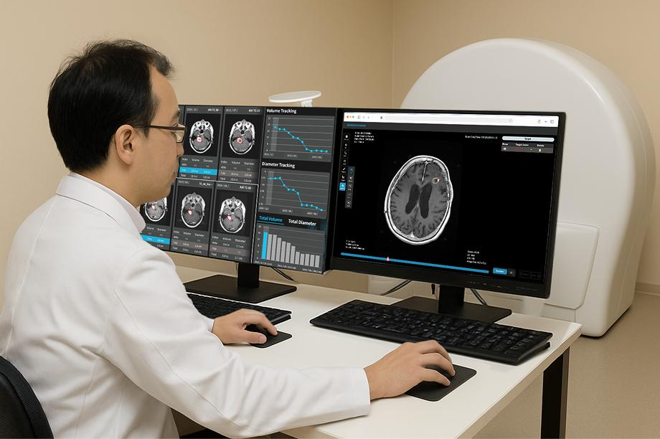
4. Need for AI Solution
AI is required in healthcare to improve diagnostic accuracy and speed. It can analyze large datasets quickly and identify hidden patterns that humans may overlook. This helps in early disease detection, which is crucial for effective treatment and saving lives.
Compared to traditional methods, AI reduces dependency on manual work and minimizes errors. It also supports doctors by providing decision-making assistance rather than replacing them. This combination of human expertise and AI intelligence leads to better healthcare outcomes.
5. AI Technologies Used
The AI-based diagnosis system uses Machine Learning and Deep Learning techniques to analyze patient data. Convolutional Neural Networks (CNN) are widely used for medical image analysis such as X-rays and MRI scans. These models learn from large datasets and improve accuracy over time.

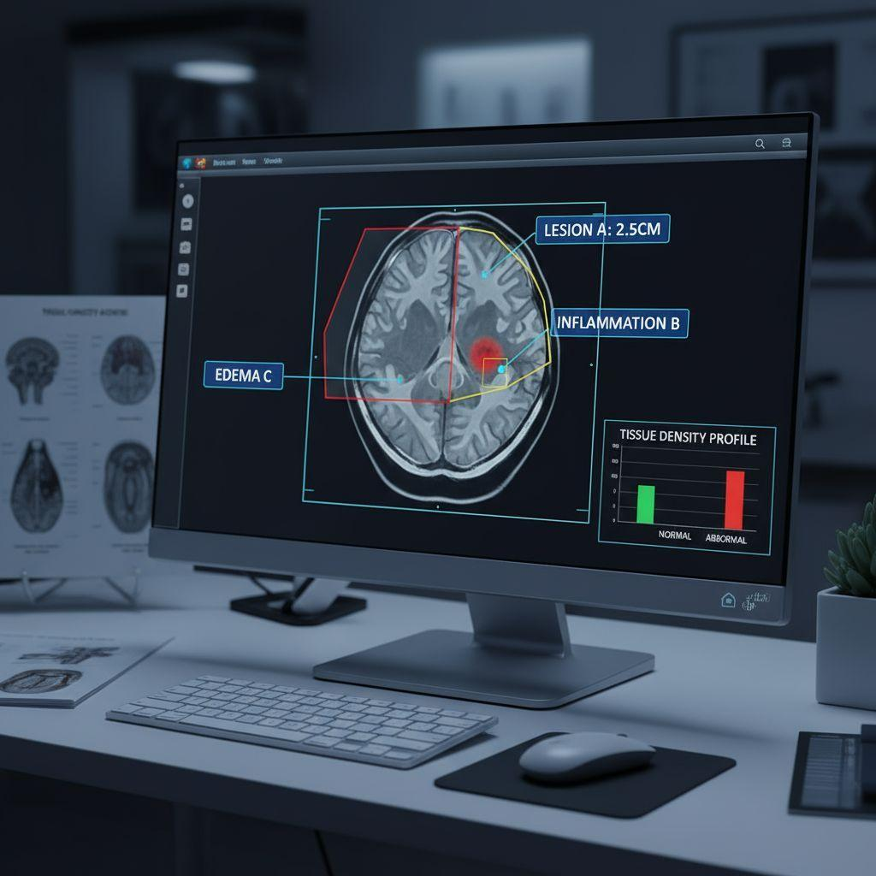
Natural Language Processing (NLP) is also used to understand patient records and doctor notes. Additionally, predictive analytics helps in forecasting diseases based on symptoms and history. These technologies work together to provide intelligent and reliable diagnosis support.
FIG 2: AFTER AI
FIG 1: BEFORE AI

6. Working Mechanism
The system collects input data such as patient symptoms, medical history, and diagnostic images. This data is preprocessed and fed into trained AI models. The system then analyze patterns and compares them with previously learned data to identify possible diseases.fter processing, the system generates output in the form of diagnosis suggestions or risk predictions. Doctors review these results and make final decisions. This workflow improves efficiency and ensures accurate diagnosis with the support of AI.
7. Data Sources and Processing
The data used in AI healthcare systems includes patient records, lab reports, medical images, and clinical datasets. This data is collected from hospitals, research institutions, and public healthcare databases. High-quality data is essential for training accurate AI models.
Data processing involves cleaning, normalization, and feature extraction to make it suitable for machine learning algorithms. Advanced techniques are used to remove noise and improve data quality. This ensures that the AI system provides reliable and precise results.
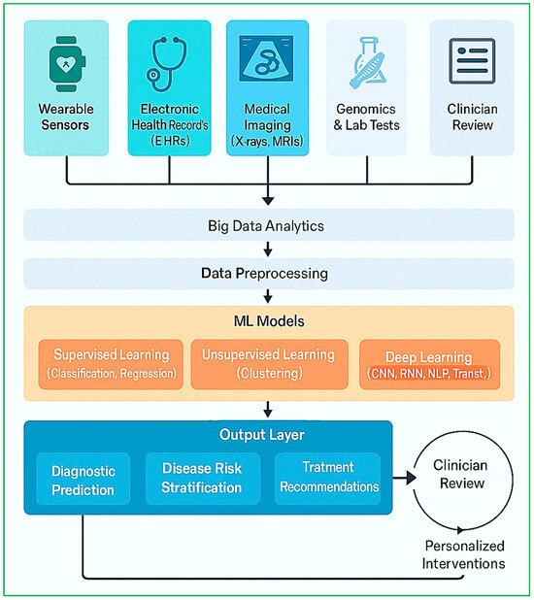
8. Real-World Implementation
AI-based diagnosis systems are widely used in hospitals and healthcare organizations. Companies like IBM Watson Health and Google Health have developed AI tools for disease detection and patient care. These systems are used for cancer detection, heart disease prediction, and radiology analysis.
In real-world scenarios, AI assists doctors in analyzing complex cases and improving treatment decisions. Many hospitals use AI-powered tools to reduce workload and enhance patient care. This shows the practical importance and effectiveness of AI in healthcare.
9. Impact and Benefits
AI has significantly improved the accuracy and speed of medical diagnosis. It reduces human errors and helps in early detection of diseases, which increases survival rates. AI systems also save time by automating repetitive tasks and analyzing large datasets quickly.
Compared to traditional methods, AI enhances efficiency and reduces healthcare costs. It improves patient experience by providing faster and more reliable results. Overall, AI brings a positive transformation in healthcare services.

Aspect | Before AI (Traditional System) | After AI (AI-Based System)
Diagnosis Method | Based on doctor’s experience and manual observation | Based on machine learning algorithms and data analysis
Accuracy | Moderate, depends on human expertise | High accuracy with pattern recognition and training data
Speed | Slow due to manual processes | Very fast with automated analysis
Data Storage | Paper records and files | Digital storage (cloud, databases)
Data Retrieval | Difficult and time-consuming | Instant access using digital systems
Medical Imaging | Manually interpreted by radiologists | AI-assisted image analysis with high precision
Error Rate | Higher due to human fatigue or oversight | Lower due to automation and consistency
Patient Monitoring | Periodic and manual check-ups | Continuous real-time monitoring using sensors
Cost Efficiency | Higher operational costs over time | Cost-effective with automation and reduced workload
Decision Support | Limited support tools | AI provides recommendations and predictions
Early Disease Detection | Difficult to detect early-stage diseases | Easier with predictive analytics
Scalability | Limited to hospital capacity | Easily scalable with digital infrastructure
Record Management | Physical file management | Electronic Health Records (EHR) systems
Accessibility | Limited to hospital visits | Remote access through telemedicine and AI tools
Personalization | Generalized treatment approach | Personalized treatment based on patient data
Learning Capability | No learning (depends on doctor knowledge) | Continuous learning using new data
Workflow Efficiency | Slower and labor-intensive | Streamlined and automated workflow
Technology Use | Minimal use of advanced tools | Advanced technologies like AI, IoT, and Big Data
Patient Experience | Longer waiting times | Faster service and improved experience
Predictive Analysis | Not available | Available using AI models

10. Challenges and Limitations
Despite its advantages, AI in healthcare faces challenges such as data privacy and security concerns. Medical data is sensitive, and improper handling can lead to serious issues. Ensuring data protection is a major challenge in AI systems.
Another limitation is the high cost of implementation and the need for technical expertise. AI systems also depend heavily on data quality, and poor data can lead to incorrect predictions. These challenges need to be addressed for better adoption of AI.

11. Future Scope and Emerging Trends
The future of AI in healthcare looks promising with continuous advancements in technology. AI systems are expected to become more accurate and capable of handling complex medical conditions. Integration with wearable devices will enable real-time health monitoring.
Emerging trends include personalized medicine, where AI provides treatment plans based on individual patient data. AI will also play a major role in robotic surgeries and remote healthcare services. This will further revolutionize the healthcare industry.
12. Conclusion
AI-based medical diagnosis systems have transformed the healthcare industry by improving accuracy, efficiency, and decision-making. Compared to traditional methods, AI provides faster and more reliable results, which helps in better patient care.
Although there are challenges, the benefits of AI outweigh its limitations. With proper implementation and continuous improvement, AI will play a crucial role in the future of healthcare and save countless lives.
13. Components and Sensors Used
- Medical Data Input Devices – Used to collect patient data such as images, reports, and vital signs.
- Sensors Module – Captures real-time health parameters like heart rate and temperature.
- Microcontroller / Processor – Processes the collected data and controls system operations.
- Data Acquisition System – Converts raw sensor data into a usable digital format.
- Cloud Storage System – Stores large volumes of patient data securely for analysis.
- ECG Sensor – Monitors heart activity and detects abnormalities.
- Temperature Sensor – Measures body temperature accurately.
- Blood Pressure Sensor – Records systolic and diastolic pressure levels.
- Pulse Oximeter Sensor (SpO2) – Measures oxygen saturation in blood.
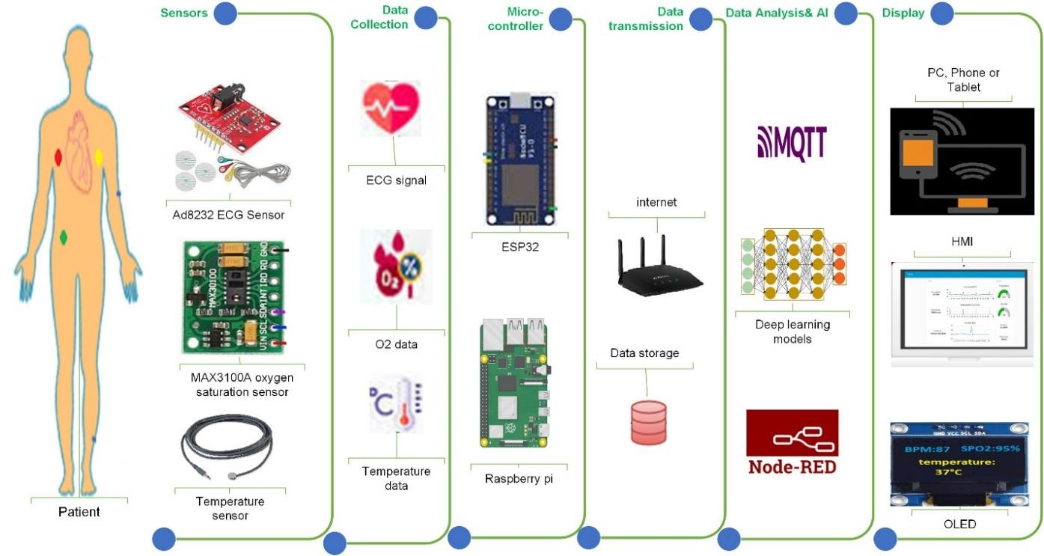

14. References
- Bhatt, J., Jain, S., & Bhatia, D. D. (2025) – Artificial Intelligence in Healthcare Diagnosis: Recent Advances
- Hoffer, E. P., James, C. A., Wong, A., & Ranji, S. (2025) – Artificial Intelligence and Medical Diagnosis: Past, Present and Future
- Zhang, Q., Wang, H., Li, H., Jiao, F., Zhou, H., & Li, M. (2026) – Application of Large Language Models in Medical Diagnosis
- Kumar, R. V., Thangamani, T., & Palaniappan, M. (2026) – Global Research Trends in AI for Medical Diagnosis
- Mirbabaie, M., Stieglitz, S., & Frick, N. R. J. (2021) – AI in Disease Diagnostics: A Critical Review

